**Project Management Plan Template**

(Group No 2)

**Project Management Plan**

**<Airlines Flight Booking System>**

|  |  |
| --- | --- |
| **Name** | **ID** |
| **ASIF AHAMMED** | **19-40020-1** |
| **A. K. M SHAHRIYAR RAHMAN** | **19-40787-2** |
| **SAMIN, FAISAL MAHMU** | **19-40792-2** |
| **JANNATH, SADIA ARABIA** | **19-39393-1** |

**Date: 27/08/2023**

**Table of Contents**

**Table of Contents**

**1.0 INTRODUCTION 3**

# 2.0 PROJECT MANAGEMENT APPROACH.......................................................................3-4

**3.0 PROJECT TITLE 4**

**4.0 JUSTIFICATION 5**

**5.0 OBJECTIVES AND PROJECT SCOPES...........................................................................5**

**6.0 OVERVIEW OF THE PROJECT 5-7**

**7.0 STAKEHOLDERS ANALYSIS 7-9**

**8.0MILESTONE LIST 9-10**

**9.0 PROCESS MODEL 10-11**

**10.0WORK BREAKDOWN STRUCTURE 11-12**

**11.0 ESTIMATION 12-13**

**12.0 RESOURCE REQUIREMENTS 13**

12.1 SOFTWARE REQUIREMENTS....................................................................................**13**

13.2 HARDWARE REQUIREMENTS...................................................................................**13**

13.3 HUMAN RESOURCE REQUIREMENTS...............................................................**14**

**13.PROJECT SHEDULE............................................................................................................15**

**14.0 DELIVERY PLAN.........................................................................................................15-16**

**15.0 RISK ANALYSIS 16-18**

**16.0 QUALITY CONTROL PLAN......................................................................................18**

**17.BUDGET..........................................................................................................................18-19**

**18.CONCLUSION.......................................................................................................................19**

**Project Management Plan**

AirAstra

Shohidul Islam Shohel

Bashundhara R/A, Dhaka, Bangladesh

17-07-2023

**Cloud-Host Cafe** is a Software Development Company based on the cloud. Over the last five years, we've provided software solutions to companies in a wide variety of industries. Dhaka is home to our headquarters, yet we serve clients across the globe. Our strategy is to learn about the specifics of our customers' businesses so that we can tailor-make solutions for them in the form of specialized software.

**Project Management Plan for Air Astra**

# 1.0 Introduction

The paper discusses all aspects of project management related to the creation of the airline flight booking system.

The document you're looking at is our project's project management plan, and it outlines in exhaustive detail how we intend to oversee and finish the project. The project manager, the sponsor, the owner, the stakeholders, the client (some portions of the project plan may contain confidential information; we should consult with our management team to determine which portions of the project plan, we should communicate to the client), and the project team are the intended readers of this document. The purpose of this article is to improve project management, make more effective use of available resources, and effectively finish the project within the allotted time.

# 2.0 PROJECT MANAGEMENT APPROACH

* This part gives an overview of how the AirAstra application development project will be managed. This spell out the jobs and responsibilities of everyone on the project team, as well as their power, how resources will be divided, any restrictions, and the most important ways to make decisions.
* Project Manager: The project manager will be in charge of planning, carrying out, and finishing the job well. They will arrange jobs, keep track of progress, deal with risks, and make sure that project goals are met.
* Software Developers: Members of this team will work on making apps for both the Android and iOS systems. They will work together on writing, testing, and fixing bugs to make sure everything works smoothly.
* UI/UX designers are in charge of making user interfaces that are easy to use, look good, and offer a great user experience.
* Quality Assurance (QA) Engineers: They do a lot of testing, find and fix bugs, and make sure the application stays stable.
* Database Specialist: Plans and runs the database system so that data can be stored and retrieved efficiently.
* Security Expert: Makes sure that the application has strong data security and user privacy means built in.
* Technical writers make user guides, installation instructions, and full documentation of projects.
* Allocation of Resources and Limitations:
* Software and Hardware Resources: It's important for a project to go smoothly that the right software tools, integrated development environments (IDEs), development machines.
* Human Resources: To meet project goals, it's important to put the right skilled people in the right jobs.
* Networking Infrastructure: For communication, trying cloud-based services, and figuring out how well real-time tracking works, you need a reliable internet connection.
* Making decisions and giving permission:
* Project Sponsor: The project sponsor will approve extra funds and make important choices about the direction of the project.

**3.0 PROJECT TITLE:**

Airlines Flight Booking System

# 

# 4.0 JUSTIFICATION:

* A flight booking agent has a very difficult time managing flight records with consumer information. By efficiently storing them, this technology will assist.
* In addition, customers may have trouble finding the expected flight schedule owing to information gaps and other issues. However, with the help of the system, they can now quickly locate their own desired flight.
* Customer can book their preferred flight with easy and accessible payment method. It will also save a lot of time and hassle.

# 5.0 OBJECTIVES AND PROJECT SCOPES:

* **Objectives:**
* This project aims to design and create software to automate key airline activities, such as online ticket buying, using an efficient and user-friendly user interface for the ordinary air traveler.
* **Sub objectives:**
* Registration Module, Accountancy Module, Inventory Module, User management Module.

The purpose of this project is to design and create software that will automate key airline activities, such as enabling online booking of airline tickets and other processes through a productive and user-friendly user interface for the typical air traveler.

1. The software system under development will have an easy-to-use user interface that focuses on people.

2. It will decrease unneeded inconveniences for travelers such delays in flights, long manual processing times, and issues with payment gateways.

3. It will make the flight agency more productive, reduce wait times, and consume fewer resources.

4. The initiative will also increase the profit margin.

**6.0 OVERVIEW OF THE PROJECT:** Below the Use Case Diagram for the Airlines Flight Booking System.

**Use case Diagram**

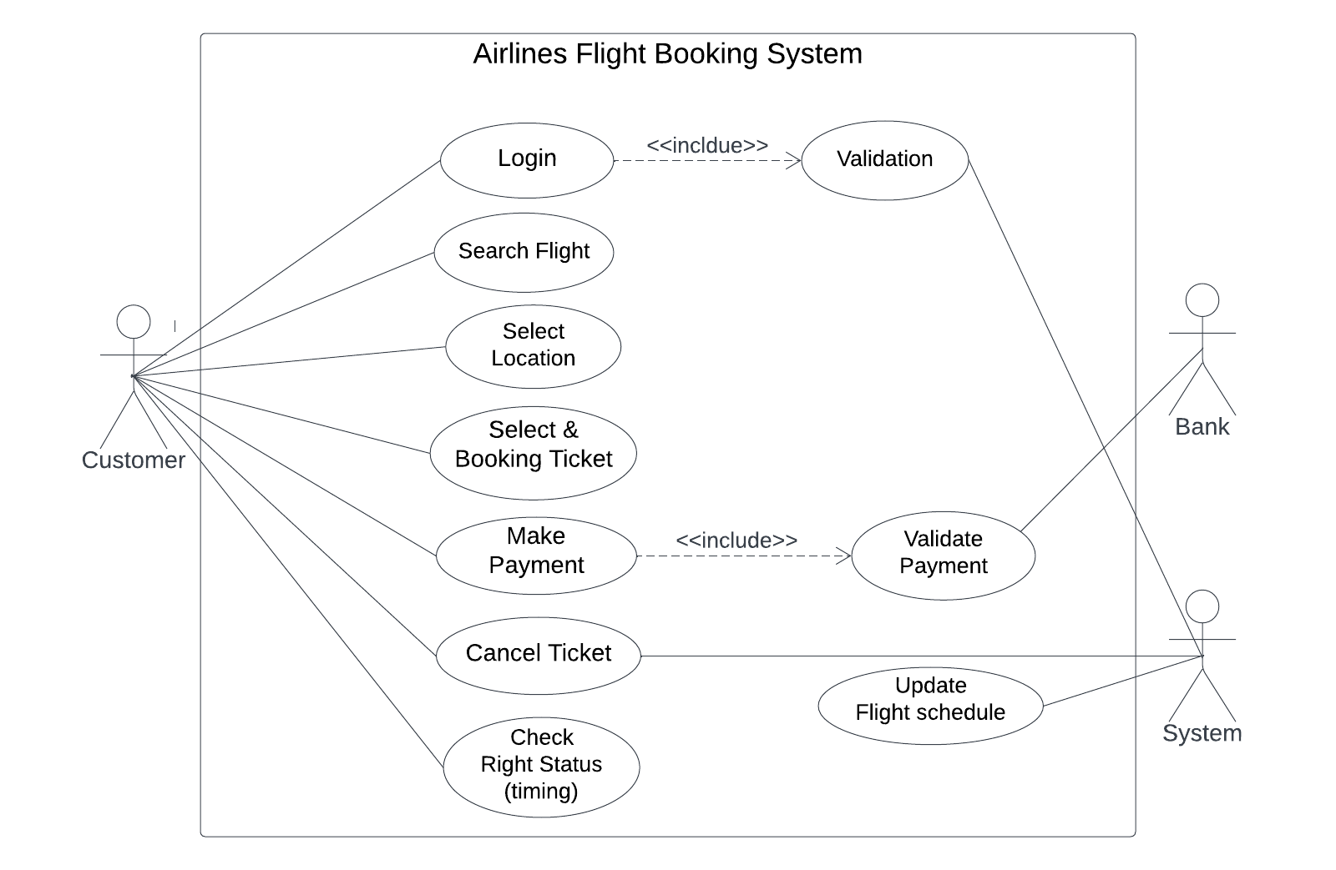

Figure – Use Case diagram for Airlines Flight Booking System.

[Use-case diagrams describe a system's high-level functions and scope. These diagrams also show how the system, and its actors interact with one another. In use-case diagrams, the use cases and actors describe what the system does and how the actors interact with it, but not how the system operates internally.]

**Block Diagram**

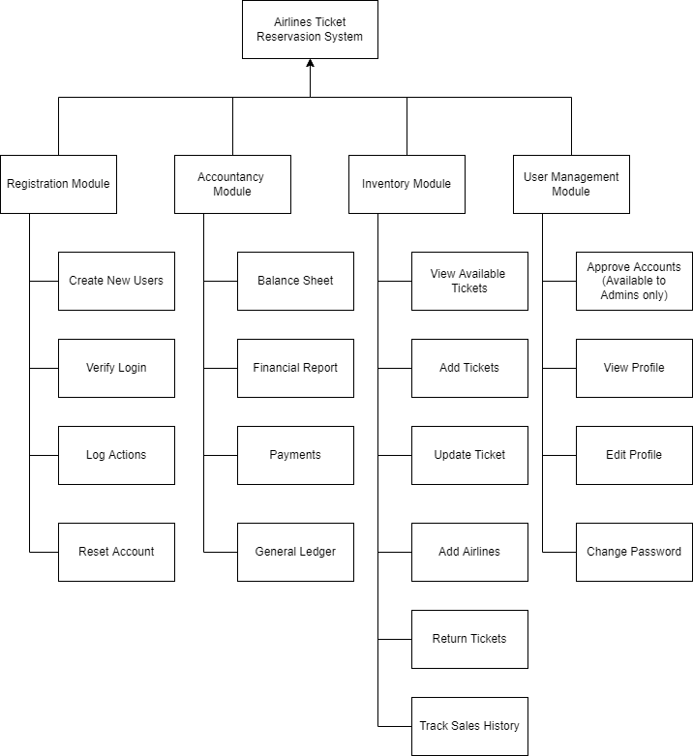

Figure: Block Diagram of Flight booking management system

**7.0 STAKEHODERS ANALYSIS:**

Anybody who is impacted by a project's positive or negative outcomes is considered a stakeholder. These elements consist of:

* Cost
* Time
* Scope
* Resources
* Quality
* Risk

We will list all of the stakeholders involved, including internal and external stakeholders. As follows:

## Internal Stakeholders

* **Software Division** - Project managers, business analysts, testers, and software engineers are some of the main internal stakeholders of the software system. Success of the business directly affects their standing. If the company incurred losses, they would be adversely affected right away in terms of their pay and way of life.
* **Operational Management** -This group is in charge of helping the mid-level management run the company efficiently every day. handling the staff of the company directly. They are responsible for making sure that everything runs smoothly and that the events start and end on time. This qualifies them as stakeholders because their lives will also be touched by the company's performance.
* **HR and Admin** -To assist the company succeed and generate more revenue, this team is in charge of hiring new employees, cutting back on unnecessary spending, and effectively employing the resources at hand. They put in time and effort to ensure that the business is running at its best, thus the performance of the business has a direct impact on them as well.
* **Board of Directors** – They observe and gather data on the current state of the business in order to develop strategic decisions and strategies to boost the organization's profitability. They are essential participants since the Board of Directors determines any significant modifications to the Media Max Airlines Flight Booking System. How they carry out their duties in making decisions will have a significant impact on the success or failure of the organization.
* **Owners** - The owners are unquestionably the most significant stakeholder because they directly and personally profit from the success or failure of the company. Their capacity to live has a big bearing on the company's performance.
* **IT Department -** This stakeholder is in responsible of ensuring network performance and monitoring the servers to make sure they are running efficiently. Each employee is responsible for resolving any hardware or computer-related issues that may arise. They participate in the enterprise even if they work for it.
* **General Staff -** The general staff members of the business are also employees; they are in charge of revising the daily schedule, keeping track of delays with aircraft, and compiling sales reports. They are also stakeholders because the success of the company affects their jobs and salaries.
* **Maintenance Workers** - These people take care of the structure. These are full-time workers that are in charge of maintaining and cleaning the facility. The equipment necessary for the organization's regular activities needs to be repaired and maintained. They are referred to as internal stakeholders since they directly profit or lose from the effectiveness of the company.

## External Stakeholders

* External stakeholders are individuals who do not directly work for the firm but are nonetheless impacted in some way by its decisions and results. The external stakeholders in our project's Airlines Flight Booking System are:
* **Passenger:** They are the most important external stakeholder in the software system. They accept the program's terms of service by using it. They make payment for the service that helps the business run. As a result, every demand is made with the customers in mind and is designed to be as convenient and comfortable for them as possible.
* **Supplier:** Suppliers are independent contractors. The suppliers profit since the business often keeps close relationships with the same suppliers over time in order to buy the items at a lower cost.
* **Bank:** The bank is a significant external stakeholder. The cooperation between the bank and the airline is a crucial element. Banks help the business in a number of ways, one of which is by offering low-interest loans to support its expansion. Additionally, the airline corporation keeps money in banks, enabling banks to make other investments. Additionally, banks receive a small portion of each digital transaction for their online digital payment gateways.
* **Government:** For each ticket sale, the government receives tax. They also receive a cut of the activity related to import and export.
* **Internet Service Provider:** The Airlines Corporation requires internet access in order to function properly. Due to this, the business only buys its internet service from respected ISPs that provide excellent service uptime and, if no significant problems occur, maintains a long-term business relationship with the same ISP. Internet service providers are among the external stakeholders.

# 

# 8.0 MILESTONE LIST

The significant milestones for the project are summarized in this part, along with the times that match to each milestone. Significant accomplishments and progress toward finishing are indicated by these milestones, which mark important points in the project's schedule. The following project milestones show how far the project has come:

|  |  |  |
| --- | --- | --- |
| Milestone | Description | Date |
| Complete SRS | Complete and record the full set of requirements, defining the AirAstra application's features and functions. | September 15, 2023 |
| Design | Create the overall AirAstra application layout, which includes the UI, system architecture, and integration methods. | October 28, 2023 |
| Complete Coding | Carry out the coding stage, translating the design specifications into working code and establishing the foundation for the AirAstra app. | December 25, 2023 |
| Complete Testing and Debugging | Test the AirAstra app thoroughly to find bugs and fix them so that it always works as expected. | February 15, 2023 |
| Documents – User Guides and Installation | In order to give users and stakeholders with thorough instructions on app consumption and deployment, you need create user guides and installation manuals. | April 5,2024 |

**9.0 Process Model to be followed:**

The **iterative development model** was selected to create this project. This was done for a variety of reasons. Using the iterative development technique, a system is created by creating small examples of each functionality. This makes it easier to quickly finish the initial scope and release it for feedback. In the iterative paradigm, you start by implementing a select few of the software requirements. These are then continuously improved in the versions that are developing until the system is complete. Implementing and evaluating a component of the program in order to identify further requirements is the first phase in this process model.

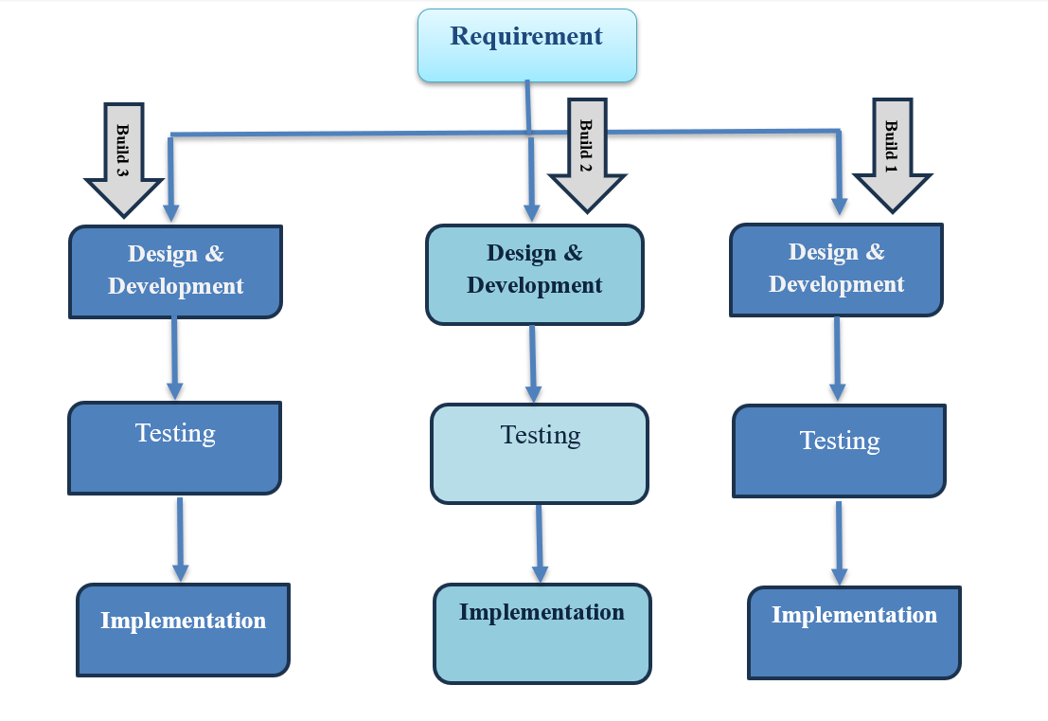

Benefits of the iterative development methodology

* Get early client input after seeing the results early in the development process
* It is simple to identify and fix any design or functioning flaws
* Manage risk and modify requirements.It is also a risk-reducing framework.
* It is easier to manage large, complex projects
* Immediately break up complex software into little, easier-to-make-and-maintain components.

Additionally, it was determined after a group discussion with all participants that the iterative software development model would be best suited for " Airlines Flight Booking System " due to receiving early, valuable feedback from the customers and being able to manage large, complex projects without much difficulty.

**10.0 WORK BREAKDOWN STRUCTURE:**

Project Plan for the AirAstra application's Initiation Phase of the Work Breakdown Structure:

* **Project Initiation**
* Define Project Scope and Objectives
* Identify Stakeholders and Their Roles Requirements Gathering
* Gather User Needs and Expectations
* Document Functional and Non-Functional Requirements
* **Iteration 1:** Initial Prototype.
* **Iteration 2:** Real time Tracking, Testing and Feedback, Refinement.

**Project Closure**

* Review Project Objectives and Deliverables
* Conduct Lessons Learned Session for Future Improvement  
  This WBS provides a high-level breakdown of the project's tasks into manageable components. Each study can be further detailed with sub-tasks and associated resources, timelines, and dependencies to ensure effective project management and execution.

**11.0: ESTIMATION:** Our software project's estimating process has taken into account two separate estimation approaches, giving us a more complete picture of the time, energy, and materials needed to bring this endeavor to fruition.

1. **Organic Constructive Cost Model (OCCM):**For the Organic Constructive Cost Model, we have considered the project's relatively small size and straightforward nature. This model is suited for projects with low complexity. Here are the calculations:
   * Project Complexity (P) = 1.05
   * SLOC Dependent Coefficient (T) = 0.38
   * Coefficient (Effort Factor) = 2.4
   * SLOC (Source Lines of Code) = 40000

**Effort Calculation:** Effort (Person-Months) = Coefficient * (SLOC / 1000) ^P

Effort = 2.4 * (6000 / 1000) ^1.05 Effort ≈ 13.99 Person-Months

**Development Time Calculation:** Development Time (Weekdays) = 2.50 * (Effort)^T Development Time = 2.50 * (13.99) ^0.38 Development Time ≈ 6.98 Weekdays

**Required Number of People Calculation:** Required Number of People = Effort / Development Time Required Number of People = 13.99 / 6.98 Required Number of People ≈ 3.89 ≈ 4 People

1. **COCOMO (Constructive Cost Model):** It is used to estimate the effort for our project. Here are the calculations:

Scale Factor (SF) = 0.9 (Assumed value based on project attributes)

Effort Adjustment Factor (EAF) = 1.0 (Assumed value to match OCCM)

Constants A and B for Intermediate Model = 2.4 and 1.05

Constants C and D for Intermediate Model = 2.5 and 0.38

**Effort Calculation:** Effort (Person-Months) = A * (Size)^B * EAF Effort = 2.4 * (6000) ^1.05 * 1.0 Effort ≈ 14.05 Person-Months

**Development Time Calculation:** Development Time (Months) = C * (Effort)^D Development Time = 2.5 * (142.4 * (6000) ^1.05 * 1.0.05) ^0.38 Development Time ≈ 7.63 Months

**Required Number of People Calculation:** Required Number of People = Effort / Development Time Required Number of People = 14.05 / 7.63 Required Number of People ≈ 3.97 ≈ 4 People

**12.0 RESOURCE REQUIREMENTS**

The feasibility of a project is directly proportional to how well it meets its resource requirements. This section details the software, hardware, and human resources that will be required to complete the AirAstra application project.

**12.1 SOFTWARE REQUIREME**

* IDE:Android Studio for Android development.
* OS: Windows 7/10/11.
* Database software: Utilize SQLite for local data storage.
* Language: Java, Kotlin (Android).

**12.2 HARDWARE REQUIREMENTS**

• Memory: 2 GB

• GPU: INTEL HD Graphics 520

• CPU: Intel Pentium Gold G6400

**12.3 HUMAN RESOURCE REQUIREMENTS**

• **The Project Manager's** job is to be in charge of the project's management, planning, and general tracking of progress.

**• Software Developer’s** should create applications for both the Android and iOS systems, making sure they work well together.

**• UI/UX designer’s** should make user experiences that are easy to use and look good to improve the user experience.

**• Quality Assurance (QA) Engineer’s** should perform thorough testing, find and fix bugs, and make sure the application is stable.

**• Database Specialist:** Plan and run the database system so that user and emergency data can be stored and retrieved easily.

**• Security Expert:** Protect user data and privacy by making sure the application has strong security measures.

**• Technical writer's** should create user guides, installation instructions, and full documentation of projects to help users and stakeholders.

**• Stakeholder’s:** Give important feedback, ideas, and support throughout the development process.

**13.0: PROJECT SCHEDULE:**

A=6, B=8, C=12, D=40, E=12,F=8, G=12, H=40, I=12 ,J=60, K=6(weeks)

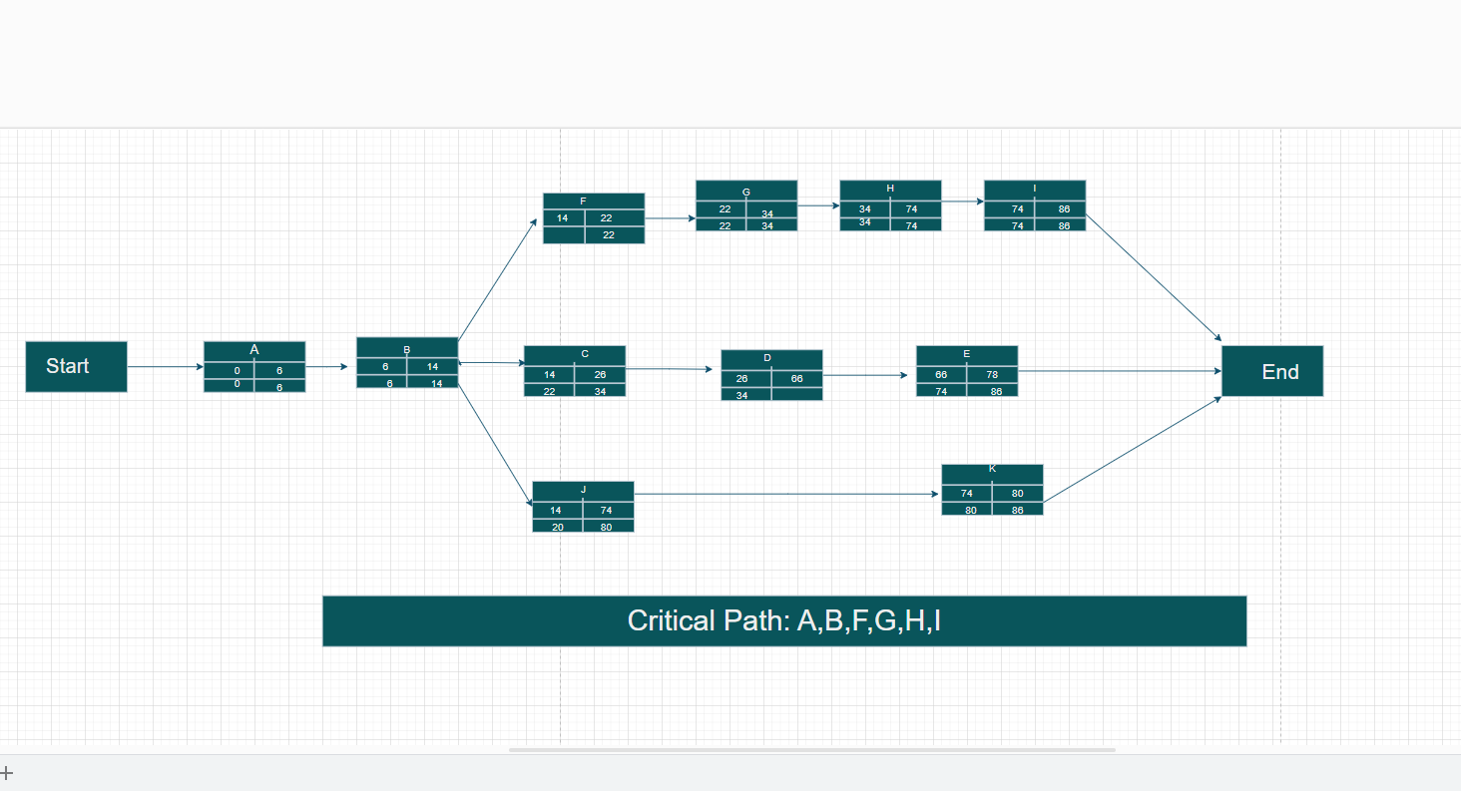

A+B+F+G+H+I = 6+8+8+12+40+12= 86

A+B+C+D+E = 6+8+12+40+12 =78

A+B+J+K = 6+8+60+6 = 80

Critical activities: A,B,F,G,H,I

**14.0 DELIVERY PLAN:**

The release plan shows the schedule and important steps that need to be taken for the AirAstra application to be finished and put into use. This part gives an outline of the project's stages, jobs, and due dates from a strategy point of view.

* **Phase 1: Starting the project and making plans for it**

It will take 2 weeks. • The most important things to do are to define the project's goals, boundaries, and stakeholders. Come up with a plan for managing the project. Give each person on the project team a job to do. Do a first risk estimate and plan for how to deal with it.

* **Phase 2: Collecting needs and making plans. This will take 4 weeks.**

Key Tasks: Make a list of all the program and user requirements. Create the user interfaces and the flow of the application. Make the application's building design. Have stakeholders look over the plan to make sure it's right.

* **Phase 3: Development and Testing. Length 8 weeks**

User authentication, and real-time tracking. Make sure unit testing and integration testing are done well. Use strict quality assurance to find and fix problems on a regular basis.

* **Phase 4: Final testing and documentation,** the project will take 3 weeks to finish. The most important tasks are to make detailed user guides, installation instructions, and project paperwork. Carry out final system testing to make sure it's stable and user-friendly. Get ready for the release of the application by doing feedback testing with the stakeholders.
* **Phase 5:** Deploy the application on app shops (Google Play Store and Apple App Store) during Phase 5- **Deployment and Launch**, which lasts **one week.**
* **Phase 6: Post-Launch Support and Iteration**

Use marketing and communication strategies to get the word out about the application's release. Keep an eye on how the first users interact with the product and fix any problems right away. Help people all the time by responding to their questions and comments. Get feedback from users for future changes and iterations.

**15.0 RISK ANALYSIS:**

The following risk table lists the potential risks associated with the proposed project. The probability ranges from 0% to 100%, with 100% representing the highest likelihood of occurrence. The impact value ranges from 0 to 10, with 10 denoting a catastrophic impact and 0 denoting little to no impact on the project.

|  |  |  |  |  |
| --- | --- | --- | --- | --- |
|  | **Risks** | **Probability** | **Impact** | **Risk Mitigation, Monitoring, and Management (RMMM)** |
|  | System failure | 10% | 9 | Make sure the units or components pass the required test cases before integrating the system |
|  | Late delivery | 80% | 7 | Make sure the project progress is on track, other take immediate action. |
|  | Technology will not meet expectations | 5% | 2 | Check whether the technologies are acquirable |
|  | End users resist system | 10% | 5 | The system passes the acceptance test, try to come to an understanding with the client |
|  | Changes in requirements | 60% | 5 | Check if the changed Requirements are feasible, try to make the requirement change before starting the development phase. Deliver the product in short increments time-boxes so that the user gets less time to finalize the requirements and change their mind. |
|  | Poor Productivity | 30% | 3 | Set achievable timeframes and a sustainable pace during project estimations to avoid burn-out of staff. |
|  | Inadequate Risk Management | 40% | 7 | Including risk in estimations. Find out the root cause and attempt for risk reduction procedures. |
|  | Poor comments in code | 20% | 5 | Train the programmers |
|  | Unrealistic schedules and budgets | 40% | 7 | Using historical data and using multiple models for estimation |

**16.0 QUALITY CONTROL PLAN:**

**16.1 Quality Goals: Functional Excellence-** Make sure the application works perfectly.

• User Experience: Create a user-friendly design that is simple and easy.

• Security and Privacy: Take strong steps to protect security.

• Performance: Make sure the system is fast and runs smoothly.

• Reliability: Make sure the application is stable and reliable.

**16.2 Activities for Quality Assurance:**

• Requirements Validation: Make sure the requirements are clear and full.

• Testing: Functionality is checked at different times with rigorous testing.

• User Acceptance Testing: Get stakeholders involved to make sure it works.

• Security and Performance Testing: Check for safety and how quickly things work.

• Usability Testing: Ask users what they think would make the design better.

• Continuous Feedback Loop: Talk to stakeholders and users to find out what they think.

**16.3 Tools to check quality:**

• Automated testing: Make sure testing is fast and easy to do over and over again.

• Code Analysis: Find problems with the code and fix them.

• Security tools: Use them to look for holes and risks.

• Tools for Testing Performance: Check how fast something is under different loads.

**16.4 Never Stop Improving:**

• comments Integration: Use comments to make improvements over time.

• The agile approach uses iterative development to make changes all the time.

• Monitoring and Analytics: Keep an eye on performance and how users act so you can make smart choices.

**17.0 BUDGET:**

Proposed project budget with profit included: 16, 43, 000 BDT

|  |  |  |
| --- | --- | --- |
| Development cost | 8*50000*16 = | 6400000 |
| Tester | 2*50000*6 = | 600000 |
| Project Manager | 1*70000*16 = | 1120000 |
| Project Co-Ordinator | 1*50000*16 = | 800000 |
| Consultant | 1*10000*16 = | 1600000 |
| Office space | 16*50000 = | 800000 |
| Utilities (water, internet, electricity, Miscellaneous) | 10000*16 = | 160000 |
| 10% overhead cost for safety |  | 1148000 |
| Total Cost |  | 12,628,000 BDT |

**18.0 CONCLUSION:**

The goal of this project will provide a fresh method for conducting ticketing operations. Both the issue and administration of tickets would be done using online technologies. However, this strategy does not stop walk-in customers from physically purchasing tickets at the box office. They can also access that. This ticketing procedure requires less papers than the previous one did.

The "Airline Flight Booking System" software package enables the senior management to submit and review executive reports online. The numerous reports had to be created manually, which took a lot of time. This solution will fix those issues and significantly reduce the amount of time required. This package's design and development will make it possible for it to more effectively satisfy the needs of the user. The real problem has been thoroughly noticed, dealt with, and anticipated.

This strategy also has the advantage of providing opportunities for future development, enabling the eventual satisfaction and updating of future customers' needs.